Pathogen Lab - Research Design

Group Members:___________________ Period: __________

With your assigned lab group, read the background information and then follow the instructions to design your experiment. Ask your teacher to initial any time it is required BEFORE moving on to the next step.

Criteria For Success
As I read the information, I am:
- Circling new vocabulary (or highlighting on the computer)
- Underlining key information that I use to answer the guiding questions
- Writing any additional questions or thoughts in the margins (or as a comment on the computer)
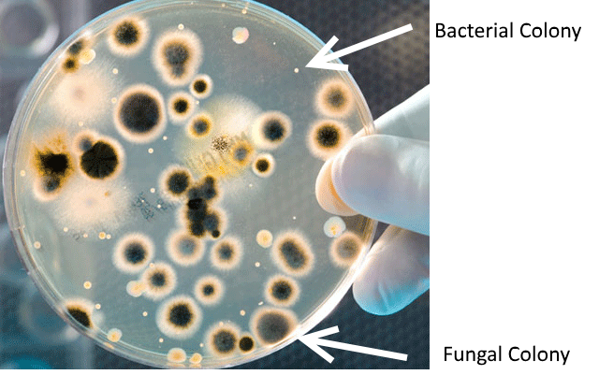
Background Information
What is Agar?
Biologists use a jelly-like substance called agar to encourage pathogens, or disease-causing organisms, to grow. Agar, made from seaweed, is a type of sugar that cells can use as food. Bacteria and fungi in particular are very good at using agar as a food source, so these pathogens can grow quickly when placed on an agar plate.
Growing Pathogens on Agar
A single cell of bacteria or fungus is too small to be visible on an agar plate. Over several days, the cell will use energy from the agar to multiply into a mass of millions of identical cells, called a colony. Bacterial colonies are relatively small. A bacterial colony the size of a letter “o” on this paper would contain several million cells! The most common household bacteria are E. coli, which is white-grey in color, and S. aureus, which is yellow-orange in color. Most household bacteria have a foul odor, similar to the smell of rotting food. This is not surprising because bacteria are responsible for breaking down rotting food!

Fungal colonies have a different appearance from bacteria due to the ability of fungal cells to spread rapidly throughout an area. On an agar plate, fungi grow into large, sometimes circular formations with one or more colors. A fungal colony may have a distinctive odor or a “fuzzy” three-dimensional texture, similar to moldy bread. Indeed, R. stolonifer, the bread mold fungus, is one of the most common fungi in the world.

Biologists use agar as a tool to determine what pathogens are living on a certain surface. For example, a biologist may swab a hospital door handle with a Q-tip and plate it on agar in order to determine what pathogens are present on the door handle.
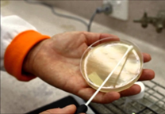
Guiding Questions
1. How does agar help pathogens to grow?
2. Name and describe two common species of bacteria.
3. How can you tell whether you have bacteria or fungi on your agar plate?

In complete sentences, respond to the following prompts.

1. Which of the following topics do you find most interesting to study? Check one.

____ [1] How many pathogens live on different solid surfaces. (Can pick surfaces outside of the classroom.)

____ [2] How many pathogens grow on solid surfaces before and after cleaning. (Must pick surfaces that are in the classroom.)

2. Write a scientific question for the topic you want to study.

__________________________________________________________________________________
__________________________________________________________________________________

3. What is the independent variable? _______________________________________

4. What is the dependent variable? _______________________________________

5. What are 3 control variables you are including in your experiment?
____________________________________________________________________________

6. Create a hypothesis for your experiment.

__________________________________________________________________________________
__________________________________________________________________________________
_____________________________________________________________________
______________________________________________________________________

7. What materials will you need?
- 2 Agar plates (one plate per partner pair)
- 1 control agar plate for the whole group (4 people)
- Distilled water
- Q-tips (cotton swabs)

Distilled water is prepared by boiling water to kill waterborne pathogens, then condensing the water vapor back into a liquid. Why do you think it is important to use distilled water instead of tap water when swabbing our surfaces?

__________________________________________________________________________________
__________________________________________________________________________________

8. Fill in the below data table. Anything highlighted should be changed to say the surfaces you will be testing. Delete the data table for the topic your group is NOT studying.

Data table for Topic 1 (different surfaces)

Date | Surface 1  (# of colonies) | Surface 2  (# of colonies) | Surface 3 - control (distilled water only)  (# of colonies)
Qualitative observations (color, size, type of pathogen, and texture of colonies; smell, etc.)

9. Graph: First determine if you are making a BAR or LINE graph. Then graph ALL of your data.
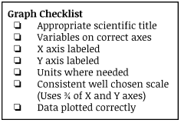

KEY

10. Conclusion: Write a conclusion for your experiment using the “Claim, Evidence, Reasoning” format.

_______________________________________________________________________________________
_______________________________________________________________________________________
_______________________________________________________________________________________
_______________________________________________________________________________________
_______________________________________________________________________________________
_______________________________________________________________________________________
______________________________________________________________________________________
_______________________________________________________________________________________
_______________________________________________________________________________________
_______________________________________________________________________________________
______________________________________________________________________________________
_______________________________________________________________________________________
_______________________________________________________________________________________
_______________________________________________________________________________________
_______________________________________________________________________________________
_______________________________________________________________________________________
______________________________________________________________________________________
_______________________________________________________________________________________
_______________________________________________________________________________________
Claim
☐ Restate the hypothesis or describe the relationship between the variables
Evidence
☐ Give two or more data sets, with units
☐ Explain the data

Reasoning
☐ Provide relevant evidence from the text
☐ Cite the evidence correctly
☐ Explain how the text evidence is connected to the claim
_______________________________________________________________________________________
_______________________________________________________________________________________
_______________________________________________________________________________________
______________________________________________________________________________________
_______________________________________________________________________________________
______________________________________________________________________________________

Bacteria Lab Setup Procedure

- Choose a solid surface to test, for example: cell phone, desk, door knob, etc. Write the name of the surface in your data table.
- Go to your teacher and collect 3 agar plates for your group of 4. Be careful when grabbing your plates as they have the agar gel inside of them. Keep your agar plate covered at all times when not in use! Do not let airborne pathogens contaminate your experiment!
- On the agar plate, use a marker to write your surface, your initials, and class period. If you will be cleaning your surface (Topic 2), use a straightedge to draw a straight line down the middle of the plate to separate before and after cleaning.
Follow the example below exactly. Label the agar plate, not the lid.
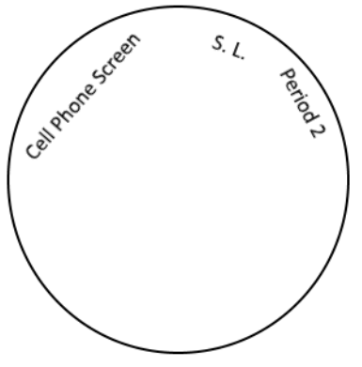 or 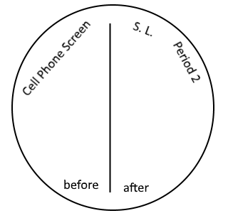

- Take one Q-tip and dip it in the distilled water. Put the lid back on the distilled water.
- Use the Q-tip to swab the solid surface you are testing.
- Gently swab the Q-tip over the surface of the agar plate, covering as much of the plate as possible. Do not push hard and do not break the gel surface. Follow the example below.
or
Topic 1 Topic 2

- Return the lid of the plate immediately.
- Repeat steps 3-6 for each surface you are testing. Be sure to read the plate’s label before swabbing!
- Each group must create one control plate, swabbing just distilled water.
- Tape each plate shut with a small piece of tape. Then put your group’s 3 plates in a stack and give it to your teacher. The plates will be kept at room temperature for two weeks to allow pathogens to grow.
- Clean up the lab table according to your teacher’s directions.

