Case Study 2: HIV/AIDS
Ruben is a 20-year-old college student majoring in Biology at the Metropolitan State University of Denver. His college provides health insurance for only $1100 per semester. Since most college students paying into the plan are young and healthy, the insurance plan can cover a large amount of medical care for a low price.
- Do a quick Google search and find the average annual cost of health insurance in the US.
Ruben has not been to the doctor for a checkup since middle school, but now he can go without paying any money out of pocket, so he makes an appointment at the campus clinic.
After going through a typical physical examination, Ruben’s doctor suggests he undergo testing for sexually transmitted infections, including HIV.
Ruben asks, “Why do you want me to get tested for HIV? Do you think I’m gay?”
The doctor replies, “Being a man who has sex with men is only one of many risk factors for HIV. Other risk factors include having multiple sex partners of any gender, having other sexually transmitted infections, exchanging sex for money or drugs, and more that are shown in this chart:
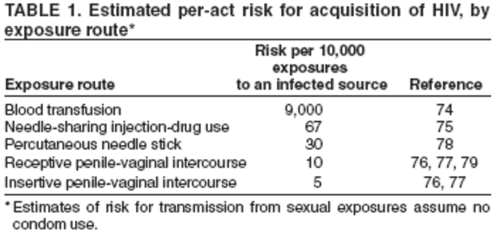
Source: Centers for Disease Control, 2005
(Percutaneous refers to a needle that penetrates the skin but does not enter a blood vessel.)
Ruben examines the chart and realizes that, contrary to what he always thought, HIV cannot be spread through coughing, kissing, or sharing drinks. It seems like it can only be spread through sexual activity and contact with blood. Ruben also notices that the highest-risk exposure by far is a blood transfusion.
- Calculate the probability of contracting HIV through a single exposure of sharing a needle containing HIV-infected blood. Show all calculations and formulas.
- Suppose you use an infected needle twice instead of just once. Does the chance of contracting HIV double? Assume that each needle use event is independent. Show all calculations and formulas.
The doctor adds, “Ruben, whether you have any of these risk factors or not, the Centers for Disease Control recommend that everyone between the ages of 13 and 64 get tested for HIV at least once. Since your insurance will cover it, now is a great time to get tested.”
Ruben says, “Okay, I guess I might as well get tested if it’s covered. Should I get tested for AIDS too? Or are they the same thing?”
The doctor replies, “HIV and AIDS are not the same thing, but they are related.”
He makes a quick sketch on his notepad to explain.
“You see, Ruben, HIV is the Human Immunodeficiency Virus, a small infectious agent that enters human white blood cells and reproduces in vast quantities. The virus uses up the human cell’s energy and resources to make copies of itself, thus weakening the human body.”
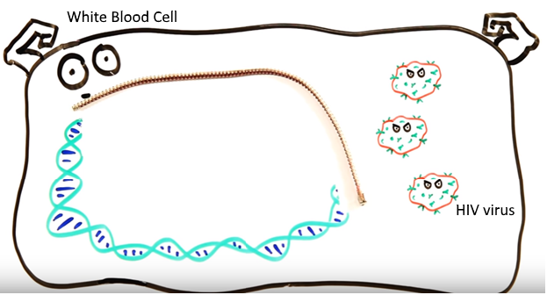
Source: ASAPScience
“Modern drugs can slow down the copying of the virus, but sometimes the drugs aren’t effective or people don’t have access to them. If the HIV virus reaches high enough numbers, it will cripple the immune system and leave the human highly susceptible to other infections. At this stage, the disease is more dangerous and is called AIDS, or Acquired Immunodeficiency Syndrome.”
- AIDS used to be called GRID. Do some brief research about when and why it was called this.
Ruben’s doctor draws a small amount of blood from Ruben’s arm and sends it to the on-site lab. It will take about 30 minutes to get the results, so Ruben sits in the waiting room and peruses an info brochure. As a Biology major, he is quite interested in the patterns of how the HIV virus spreads.
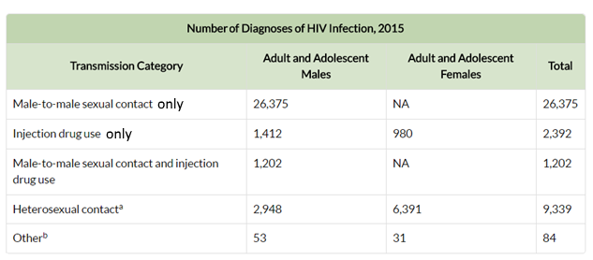
Source: Centers for Disease Control, 2017.
- How many adult and adolescent males were diagnosed with HIV in 2015?

- What portion of diagnoses in 2015 were from males engaging in injection drug use only? Show all calculations and name the type of frequency you are calculating.

- What is the probability of transmitting HIV from heterosexual contact, given that the person diagnosed was female? Show all calculations and name the type of frequency you are calculating.
- Name two categories in the table that are mutually exclusive. Explain what this means.

Many people wonder why HIV is more common among gay men then among straight people. To make sense of this, we must understand both historical and biological aspects.
- In the 1980s, there was no sex education for gay people. Gay men didn’t use condoms because there was no risk of pregnancy, and they were unaware of the risk of STIs. In this period the HIV virus spread quickly throughout gay communities until someone realized the pattern.
- Today, the rate of new HIV infections in the gay community has gone down dramatically due to better education and availability of preventative treatment. However, because the infection cannot be reversed, the gay community still feels the effects of history.
- Gay men tend to engage in sex acts that are higher risk. Anal sex is more likely to transmit the virus than penile-vaginal sex due to the biological qualities of the body parts involved
Ruben sees another brochure in the waiting room titled, “Living With HIV/AIDS”. He remembers hearing that people with HIV are living longer and longer due to better medications being developed. He wonders how long a person can expect to live after being diagnosed with HIV.
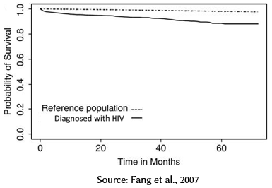
- Use the graph to estimate the probability of surviving for 5 years after being diagnosed with HIV.

- Why is it helpful to use a reference (or control) population? Who would you choose to be in a reference population?

Ruben looks at the clock. Ten more minutes until he gets his test results. Still bored, he looks at the information pamphlet for the test itself – the HIV Rapid Antibody Test. He is surprised to see that it is not 100% accurate. Some people get a positive test result but are actually HIV-negative, which is called a false positive. A few people will get a negative test result but actually have the HIV virus, which is called a false negative. The pamphlet contains the results of the clinical trial that was performed before the test was released for public use.
 | Actual + | Actual - | Total
Test + | 26 | 11 | 37
Test - | 1 | 328 | 329
Total | 27 | 339 | 366

- Circle the number of false positives and box in the number of false negatives in the table.
There is no one number to describe the “accuracy” of a diagnostic laboratory test. We must look at two different numbers —the sensitivity and the specificity.
Sensitivity refers to how correct a test is when used on people who have the virus. If a test is not sensitive enough, it will let some HIV+ people slip by and not detect the presence of the virus. In other words, sensitivity is P(patient tests + | patient is actual +).
We can connect this to our general formula for P(A and B):
$$P\left(A and B\right)=P\left(A\right)*P\left(B | A\right) \\ P\left(tests+ and actual+\right)=P\left(actual+\right)*P\left(tests+ | actual+\right)$$
Manipulating to isolate for the desired variable, we get:
$$\frac{P(tests+ and actual+)}{P(actual+)}=P\left(tests+ \right| actual+)=Sensitivity$$

Since both numerator and denominator will be divided by the total sample size, the sensitivity ratio can be written more simply as:
$$\frac{\# who test+and are+}{total who are+}=Sensitivity$$

- Calculate the sensitivity of the HIV Rapid Antibody Test. Show all calculations.

- Is sensitivity an example of joint relative frequency, marginal relative frequency, or conditional relative frequency? Explain.

Specificity refers to how correct a test is when used on people who don’t have the virus. If a test is not highly specific, it will falsely identify some people as HIV+ when they actually don’t have the virus. In other words, specificity is P(patient tests - | patient is actual -). It is calculated by the formula:
$$\frac{P(tests- and actual-)}{P(actual-)}=P\left(tests- \right| actual-)=Specificity$$
Or by the simpler formula:
$$\frac{\# who test-and are-}{total who are-}=Specificity$$
- Calculate the specificity of the HIV Rapid Antibody Test. Show all calculations.

- Is specificity an example of joint relative frequency, marginal relative frequency, or conditional relative frequency? Explain.

Ruben starts thinking, “What if I test positive? How will they know it’s not a mistake?”
When a person tests positive on their first HIV test, they are not automatically considered HIV-positive. The person will undergo followup testing with more expensive, higher-specificity tests to confirm the initial test result.
- Why is followup testing necessary before making an HIV diagnosis?
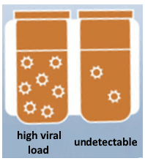
For many people who are HIV+ and taking an effective medication, the number of viruses in their bloodstream is so low that it is called an undetectable viral load. A typical HIV test is not sensitive enough to detect the virus in this person’s blood. Furthermore, the probability of a HIV+, undetectable person transmitting the virus to a sexual partner is "virtually zero." (Rodger et al., 2014).
On the bulletin board in the clinic, Ruben sees a poster from the CU Anschutz Medical Campus recruiting participants for a clinical drug trial. The drug being tested is a new type of Pre-Exposure Prophylaxis (PrEP) which is meant to be taken by HIV-negative people in high-risk groups. The drug is thought to dramatically reduce the risk of acquiring HIV from an exposure. Before the drug is put on the market, a clinical trial must be performed to assess its safety and effectiveness.
180 HIV- people in high-risk groups (men who have sex with men, injection drug users, etc.) volunteered to take part in the trial, but the researcher only has the funding to take 30 participants. How many ways can the researcher choose 30 participants out of a pool of 180? Show all formulas and calculations.

When the clinical trial is finished, the researchers conclude that a daily dose of PrEP reduces the risk of HIV transmission by about 90%. For people in high-risk groups who can afford it or have insurance coverage, the advent of preventative drugs like PrEP revolutionary. In 2015, gay males in London began taking PrEP and this resulted in a 40% drop in the rate of new HIV infections (Wilson, 2017).
- An old saying goes, “An ounce of prevention is worth a pound of cure.” Research and compare the price of PrEP drugs to the price of HIV treatment drugs. Is there value in prevention here?

Discussion
Ruben’s doctor calls him back into his office to get the test results. The paper containing the result does not have his name on it, just an identification number to protect his privacy.
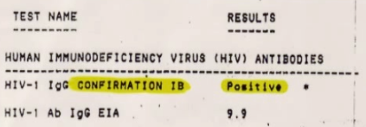
Ruben has tested positive for HIV. Many thoughts go through his head. How did I contract the virus? Is the test right? What’s going to happen to me? Should I take another test?
In the space below, summarize the situation and discuss potential next steps. Refer to the information given in this project. You may use other sources (with proper citation) as well. You will share this response in class. (300-400 words)

Grading Rubric
Name: _________________________________________________
 | 1 point | 3 points | 5 points | Score
Precision | Most or all calculations and written responses are imprecise and the student’s analysis is obscured by errors. | Some calculations and written responses show precise use of the data, while others contain errors and omissions. Claims are made without data and sources to back them up. | All calculations are carried out accurately. All written responses show thoughtful analysis of the data with reference to reputable sources (if applicable).
Communication | Most or all calculations and written responses are difficult to understand. | Some calculations and written responses are clearly communicated, while others are confusing and difficult to understanding. | Each step of the calculation process is shown clearly for the reader to follow. All written responses are clear and concise with proper use of vocabulary.
Discussion Section | The discussion omits essential elements of the case study and gives incomplete coverage to the potential risks and options. | The discussion touches on the essential elements of the case study and gives a basic assessment of potential risks and options. | The discussion includes a thorough summary of the case study and a fact-based assessment of potential risks and options.
Presentation | The report is disorganized and difficult to read. The report is turned in multiple days late. | The report is readable but not presentable in appearance.  OR, the report is turned in late. (Additional points are deducted for additional days late.) | The report appears neat and professional. The report is submitted on time as either a soft or hard copy.
Work Time | The student used little of the work time efficiently and their actions did not allow others to work. The student did not seek help when needed. | The student used some work time efficiently and their actions mostly allowed others to work. Computer use was off-task at times. | The student used all work time efficiently and their actions also allowed others to work. Computer use was appropriate and on-task. The student sought help when needed.
Overall Score |  |  |  | /25

Case Study References
AsapSCIENCE. "The Science of HIV/AIDS." YouTube. YouTube, 26 Nov. 2015. Web. 08 May 2017.
Fang, C.T., Y.Y. Chang, H.M. Hsu, S.J. Twu, K.T. Chen, C.C. Lin, L.Y.L. Huang, M.Y. Chen, J.S. Hwang, J.D. Wang, and C.Y. Chuang. "Life Expectancy of Patients with Newly-diagnosed HIV Infection in the Era of Highly Active Antiretroviral Therapy." QJM: An International Journal of Medicine. Oxford University Press, 01 Feb. 2007. Web. 08 May 2017.
"HIV/AIDS." Centers for Disease Control and Prevention. Centers for Disease Control and Prevention, 31 Jan. 2017. Web. 08 May 2017.
MacKenzie, T., A. H. Gifford, K. A. Sabadosa, H. B. Quinton, E. A. Knapp, C. H. Goss, and B. C. Marshall. "Longevity of Patients with Cystic Fibrosis in 2000 to 2010 and Beyond: Survival Analysis of the Cystic Fibrosis Foundation Patient Registry." Annals of Internal Medicine. U.S. National Library of Medicine, 19 Aug. 2014. Web. 08 May 2017.
Rodger, A. et al. “HIV transmission risk through condomless sex if HIV+ partner on suppressive ART: PARTNER study.” 21st Conference on Retroviruses and Opportunistic Infections. Boston, abstract 153LB, 2014.
Wilson, Clare. "Massive Drop in London HIV Rates May Be Due to Internet Drugs." New Scientist. NewScientist, 09 Jan. 2017. Web. 08 May 2017.

